INFORMATION SOCIETIES TECHNOLOGIES (IST)
PROGRAMME


<Logo>

Specific Targeted Research Project (STREP)

Proposal full title: Semantic Infrastructure for Paid Content
Proposal acronym: SIPACO
Date of preparation: January 05, 2005
Type of instrument: Specific Targeted Research Project
List of participants:
- University of St. Gallen, Switzerland
- University of Paderborn, Germany
- Salzburg Research Forschungsgesellschaft, Austria
- SAP AG, Germany
- N.B.

Coordinator name: TBD
Coordinator organisation: TBD
Coordinator e-mail TBD
Coordinator fax: TBD

Contents
Contents 2
B.1 Scientific and technological objectives and state of the art 4
B.1.1 Goal of the Project 4
B.1.2 Main Research Topics 7
B.1.2.1 … Technology 7
B.1.2.2 … 9
B.1.3 State-of-the-art and how SIPaCo will enhance it 10
B.1.4 Relevance to the objectives of the IST Priority 13
B.1.5 Something 13
B.1.5.1 Something more 13
B.2 Potential impact 13
B.3 Outline implementation plan 13
B.4 Description of the Consortium 13
B.5 Description of project management 13
B.6 Project resources 13
B.7 Detailed implementation plan – first N months 13
B.8 Other Issues 13
B.9 Gender Issues 13
B.10 References 13

Summary

Proposal full title: Semantic Infrastructure for Paid Content

Proposal acronym: SIPACO

Strategic objective:

Proposal abstract:

Scientific and technological objectives and state of the art

Goal of the Project
Distributed content production, publication, distribution, trading and usage (content value chain), such as by web logs or wikis, decompose and reconstruct the value chain of the whole media industry. The main focus of these initiatives lies on free content that is provided exempt from charges as a public good. Additionally to free content, the media industry is based on premium content that provides values to user communities for which market prices can be generated. With innovative technologies for the content value chain, premium content can be generated by any individual or organisation and opens up a huge potential for knowledge sharing and trading on the basis of digital environments. Currently the market for such paid content is fragmented, mainly restricted to traditional content providers and enclosed into proprietary technical infrastructures that hinders the rapid development of an innovative industry for paid digital contents. Premium content that generates market prices, for instance, can be a value-add for products and services, such as buying decision making process or service situations, or can be a (digital) product by itself that is derived from experience of products or specific knowledge of individuals or organisations.

SIPACO focuses on the electronic market interface between suppliers and consumer of paid content by leveraging the potential of semantically annotated paid content that is mediated between communities via distributed technology infrastructures. […] Key elements of SIPACO are
- Explicit semantically rich contract models for paid content (properties and features of paid content, tasks that are associated to paid content, modal logic descriptions)
- Trading protocols for paid content (→ library)
- Contract protocols for paid content (→ library)
- Dynamic semantic cataloging: Consumer-sided dynamic semantic-driven aggregation of product offering within the context of paid content
- Foundational semantic negotiation and mapping between semantic library and catalog services
- Open, distributed infrastructure with different transportation binding for paid content, such as Peer-to-Peer, …
  - information services (catalog and library services)
  - signaling services
  - contracting services (creation, negotiation)
  - contract execution services (payment, logistics, IPR management, royality management, arbitration, syndication, termination)
- Ontology-based domain end user language (visual graph modelling); end user language will be used for push (publish/subscribe scenarios) and pull (request/response) scenarios of paid content distribution.
- service interface descriptions (structured pre- and post-conditions)
- [Marc: discussion required: OWL-S/graphs]) The description of a service interface according to an ontology should reflect the functional nature of a service by providing a semantic description in the form of pre- and post-conditions (a style of description also known from contract-based programming). The language for describing pre- and post-conditions should allow developers to build complex structures over the terms of an ontology and not only be based on single input and output concepts as they are provided by today’s technologies. The advantage of supporting complex pre- and post-conditions is that the ontology itself can contain very common and basic terms of business (which may be rather stable), and interface descriptions can combine these terms in an individual way to express their specialized semantics (behavior). Thus, we achieve stability in the ontology and flexibility in describing innovative services.
- Existing ontology languages like OWL or DAML+OIL are industrial standards to enable the creation of ontologies. OWL-S (formerly DAML-S) is based on OWL and provides an ontology markup language to represent capabilities and properties of Web services. Its goals are to achieve automatic Web service discovery, invocation, composition, and execution monitoring. OWL-S is for describing a Web service based upon three basic types of information: provider information (simple contact information), functional descriptions, and further information for specifying the characteristics of a service (mainly by references to existing taxonomies). The most interesting part for the description of a service interface is the functional description. It describes the input, output parameters, and additionally pre-conditions (called external conditions that must be true for the execution of a service) and effects (called side effects of the execution of a Web service). The pre-conditions and effects are logic formulas to restrict the input and output parameters. That means, the functional description isdescription is on the same level as a WSDL document of a service, it does not yield information on the service’s semantics according to a standardized ontology.
- Furthermore, the description of a service interface should be based on models. Models provide abstraction from the detailed problems of the implementation technology and allow users to focus on the more abstract tasks. In the field of software engineering, the diagrams of the industry standard UML (Unified Modeling Language) have become very successful and are now an established part of system’s development. Models are becoming even more crucial to software development as implementation artefactsartefacts can automatically be generated from the models, thus saving time and guaranteeing consistency. Offering modeling support for the description will have several further advantages: (1) Models are independent of the target language(s). It is thus possible to derive the different specifications/implementations consistently from one source. (2) Models are visual. Structures (like ontologies) can be understood much more intuitively if they are presented in a visual manner (as compared to pages of OWL code). Software engineersengineers have long since recognized this feature of visual languages and make heavily use of it. In the semantic Web field this idea resulted in UML class diagram representations which are equivalent to DAML+OIL or OWL specifications. (3) Models are becoming more important and a number of tools for using models in the field of software engineering are available. Basing the description of service interfaces on models allows one to reusereuse existing information and tools.

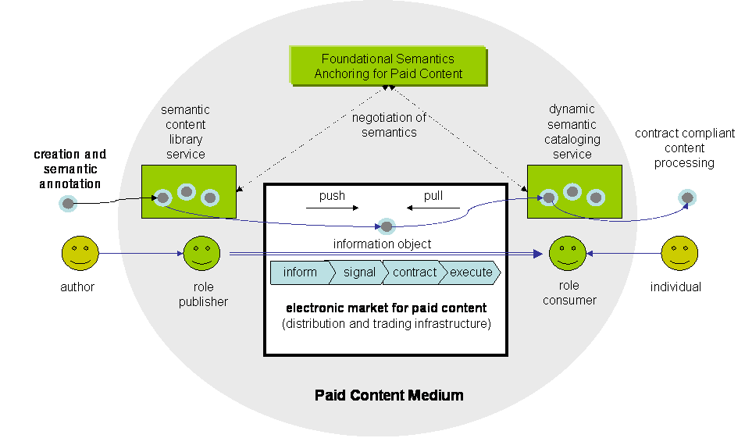
Figure 1: Overview SIPACO

For the identification of available content sources we will develop end-user languages that on one hand easily allow the specification of premium content that a user is looking for and on the other hand can be translated into requests that can be used by semantically enriched services in web-based environments. Because semantic web retrieval formalisms such as RDQL presuppose dedicated technical training, widely-used content environments require easy-to-learn user languages that efficiently facilitate content-oriented requests.
End-user languages or domain-specific languages are often tailored to a particular group of users or problem domain. They are specific for a user group.or domain throughthrough the appropriate use of notations and abstraction.. End-user languages are developed by usability and language engineers together with domain experts for people or scenarios where the development of solutions in a general purpose language is often a too daunting task for people typically not trained as software engineers. In principle, visual languages as opposed to textual ones would often be ideal for use as end-user language. For a large number of specialist user groups there exists a natural and intuitive visual representation of artefacts in their domains, which is often what practitioners in these fields have been using all along, which reduces training costs and lowers the barriers to acceptance.
This end-user language is translated by a two-step process via a graph language into underlying semantic web representation formalisms. This provides an innovative, layered approach by integrating the strengths of the visual modelling capacities of graph languages with emerging interoperability of semantic descriptions of content and services in web environments.
Graph languages serve in our approach as a general purpose language that can be used by software engineers. Additionally, language engineers can use this graph language as abstract syntax for specifying new visual end-user languages. That means, the graph language serves as a language middleware that is independent from the implementation language and the end-user language. The working hypothesis is that this graph language will be designed in a way that its expressiveness will be sufficient for the identification and description of available content sources. End-user languages may be less expressive, depending on the end-users’ anticipated tasks when using the language. They will typically differ in notation and may provide only restricted views on the language middleware of what is relevant to the end users. Software engineers can directly use the graph language for specifying their solutions.
The abstract syntax of the graph language will be defined by defining an adequate meta-model. As an architectural basis we will use the Unified Modeling Language (UML). The UML becomes increasingly important as a modelling language across various domains like multimedia application design or workflow modelling. The UML offers meta-modelling support for developing domain-specific extensions. The domain-specific meta-models allow language designers to add more semantic depth to the standard meta-model and thus build a foundation for model analysis and code generation. The good meta-modelling support within the UML enables developers to seamlessly integrate new extensions into CASE tools and build special-purpose solutions outside of the standard UML applications.
The abstract syntax of the graph language (e.g. the meta-model extension of the UML) is then used for defining a translation into semantic web representation formalism. Because of the layered approach different semantic web representation formalisms can be used without changing the end-user language.

Figure 2: layered approach

Requests are propagated to web services by binding them to different transport layers, such as peer-to-peer or directory-based approaches (e.g., UDDI). Within SIPACO we will implement a paid content infrastructure on the basis of different transport systems and evaluate within concrete application domains which types of business models can be supported.

Figure 3: layered approach

Responses are semantic descriptions of digital content that provide information on which business and trading rules apply (business requirements) and how the content can be used (organisation and task environments). This information is organised by local aggregation services that provide dynamic catalogues to users (→ dynamic semantic catalogue services). [template approaches?]

Users will evaluate semantic descriptions of aggregated content offerings and enter into trade interactions with selected providers on the electronic market by signalling their interest. Trades will be based on trading protocols that are specified by business requirements of selected content product. Trading protocols govern the communication between trading agents with the goal to generate a mutually agreed contract or to exit from negotiations. Not in all cases, agents will use a common ontology for trading. Therefore communications mediated by a trading protocol will be translated into ontological languages of participating agents (→ negotiation of semantics). This translation process will be guided by a foundational ontology approach that provides a minimal ontological denominator between web services (→ foundational semantics anchoring for paid content).

[Wolfgang: Semantic contract for paid content: POSL, BPEL, PIC, ]

The intermediate graph representation language provides means for high-level specification of pre- and postconditions (design by contract approach) that are to be satisfied by semantic annotations of content products hosted in heterogeneous and distributed web service environments.

This architecture provides an innovative and unique infrastructure for semantically annotated premium digital content that can be traded in distributed business environments.

[Application domains and examples]

knowledge-intensive … . The project scenarios are applicable to … such as … in complex tasks that highly rely on … . Typical domains are … , etc.

An example of such an application area currently attracting considerable interest is … . In essence … . The emergence of such … offers new service opportunities to ICT companies.

[Goals]

The goal concentrates on … . Efficient integration and sharing of information sources as well as the utilization of the knowledge of all involved people are crucial, while issues of intellectual property rights, confidentiality, and trust have be respected. Furthermore, social aspects, methods of collaboration and communication, tools and required IT collaboration infrastructure will be considered.

[Exploitation issues]

The project should define a seamless technology framework and environment, which is unobtrusive and easy to use, robust and suitable for everyday use. The framework must allow flexible and rapid customization to the desired needs and socio-economic background. It should be easy to manage and maintain (regard it as a kind of utility such as telephone or power-supply) over the complete lifecycle of the project. It must be easy, simple and cheap enough that also SMEs can participate. It requires collaboration across organisational boundaries as well as different IT infrastructures.

Another key aspect is understanding the computational and knowledge resources or background information, required by individuals and communities within the project; and combining available resources as required. Another aspect is to be aware of the individual skills and resources contributed by each partner starting from the partner selection process over the whole lifecycle of the project (react to changes).

Main Research Topics

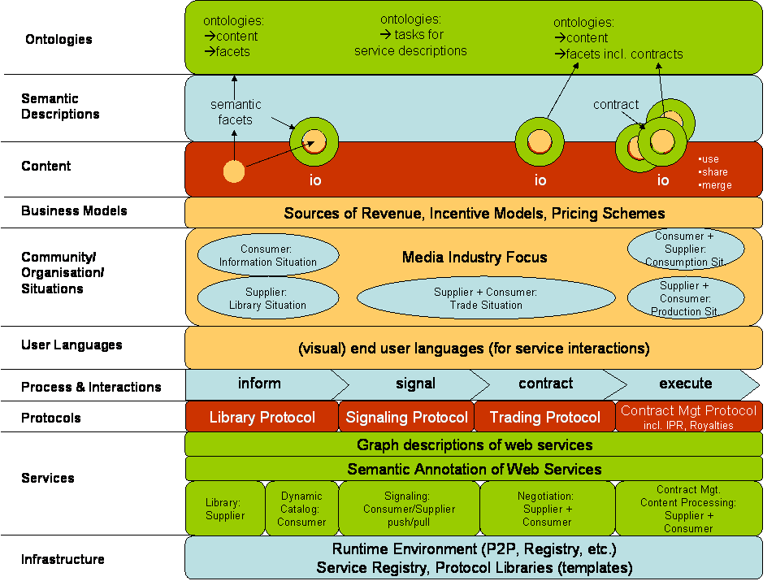
figure 4: SIPACO landscape (draft)

… Technology

This includes a range of technologies which enable … . Amongst the technologies to be integrated are:

A: Web-based semantic contract modelling for paid content [MCM, …]

[→ WMA: information object = paid content + contracts (→ discussion on naming: KCOs etc.)]

[→ WMA: electronic contracts for paid content]

[→ WMA: prospective and concession contracts]
Paid contents do not have to exist before signing a contract on paid contents. Hence, electronic contracts on paid contents can be separated into two classes: (1) contracts that govern the production (prospective contracts or short p-contracts) and (2) contracts that govern property and usage rights of paid contents (concession contracts or short c-contracts). An example for c-contracts are job contracts that generally regulate how future paid contents are appropriated on an abstract level [WMA: example from content industry]. Consulting contracts generally integrate p- and c-contracts. Procedural elements such as milestone plans or project management plans that determine procedural elements of digital content production whereas constraints on intellectual property rights constrain how digital contents are handled after production.
Thereby the focus lies on concession contracts with direct translations of traditional contracts into digital domains that govern packaged digital products. For instance, packaged software products are traded online on the basis of "webwrap", "clickwrap" or "point-and-click" agreements [Berenstein, Campbell'02]. Electronic contracts are a crucial element for specialisation and cooperation on market structures. They are time limited, procedural, legally binding interfaces to capacities that are provided by digital services. As any contract, they represent voilitions between economic actors to exchange digital contents of a certain quality in a mutually agreed and enforable manner. Digital contents and exchange behaviour are represented by quality descriptions of intended assets and description of procedures how paid contents are to be produced and exchanged.

[Implicit and explicit contracts]
At the eve of fully automated electronic contracts, we will distinguish between explicit and implicit contracts. Explicit contracts are fully formalised and assertive in a particular market situation for paid content. In contrast, implicit contracts are grounded either in social agreements that are not explicated in the situation of a content trade or in overarching explicit contracts that are not used in the particular market process. Therefore, the difference between implicit and explicit contracts is the level of ambiguity. The result of this phase is a binding contract including obligations and rights on both sides as far as they are not already defined by overarching contracts. If the situation is dominated by social ties contracts will be implicitly defined whereas formal relations of paid content market situations tend to use explicit contracts. The execution of contracts is performed during the execution phase in which information is exchanged against direct or indirect values (reputation, altruism, reciprocity [Davenport, Prusak'98]). The result of this phase is the correct termination of a business transaction, i.e. a successfully executed contract or a mutually agreed form of cancellation of the transaction.

[Media framework]
In the following, we present an integrated framework for the production (p-contracts) and usage (c-contracts) of paid content according to negotiated contracts.
The "Media Reference Model on Paid Content (MRM-PC)" provides a means for constructing electronic contracts for paid contents. As discusses above, contracts are abstractions on digital contents with enforceable operational interfaces. Digital contents that pre-exist before a voilition of economic actors can be traded by c-contracts (figure 5). In the other case, a compound contract is required consisting of a p-contract and a c-contract.
[→ WMA: figure and description of MRM-PC]
For existing paid contents, such as documents, p-contracts are reduced to delivery operations. P-contracts are abstract programs that control implementations. Paid contents are produced as side-effects of p-contract implementations. Each paid content is bound to at least one c-contract.

figure 5: Digital content binding with contracts
In a situation Sp of an electronic market place for paid contents, two economic actors, customer C and supplier S, agree on a p-contract for generating (G) a digital content DC that will be available for usage (U) under a set concession contract Cx in situation Sx (igure 1). The digital content DC might be re-committed to other concession contracts for a particular situation Sx.

[→ WMA: Tasks on paid content according to contract facets]
- create
- commit, re-commit
- modify
- copy
- delete

[Paid content services → to be decided whether paid content services will be part of SEPACO]
Dominantly digital contents are comitted to exactly one c-contract that is persistent over time. In cases that economic control requires an artificial limitation of content duplication or the nature of the provided content is functional, digital content is integrated into paid content services (PCS). Examples are node-locked software systems, online learning courses based on application service providing, online games, and video streams that cannot be downloaded [WMA: examples from media industry].

Based on this, we define a paid content service PCS as a relation over digital contents PC that are provided by this service, p-contracts P, a set c-contracts C and situations S. For digital content services that pre-exist, P will be empty. Similar to contracts on service-level agreements (e.g, [Farrell+'04]), p-contracts determine procedures for the generation of digital content services. Activities by actors and interactions between actors are determined on a conceptual level similar to the approach proposed by [Oberle+'04].

[→ WMA: contract descriptions]

[→ WMA: Service description: creation, negotiation, signing, execution, maintenance,arbitration, termination]

[Negotiation services]
Economic actors ascertain intended economic behaviour by negotiating and signing contracts. Negotiation is a means for economic actors to communicate and compromise to reach mutually beneficial agreements [Pruitt'81]. [→ WMA: negotiation services]

[WMA: contract network; merging contracts; propagation]
[WMA/SAP?: IPR modelling; royalty accounting; process integration; …]

[Please add your acronym where you intend to contribute; Feel free to add research topics]

B: Trading and contracting protocols […, MCM, …]

C: Foundational semantics (negotiation and contracting) [N.N.]

D: Graphical, ontology-based end-user language and service interface descriptions […, UPA, …]

E: Dynamic semantic cataloging […, MCM, …]

F: Open, distributed infrastructure for paid content [N.N.]

G: Business models for tradtional and innovative media industries [MCM, …]

General comments

In general work will consider … .

…

??? will be the overall research goal for SIPACO. Topics A, B, and C focus onto contracting issues that are associated with trading of paid content as the important keystone of electronic markets for information goods. Topic A addresses semantically annotated data structures of contracts that are generic and flexible enough to represent static and dynamic control information for governing the use of paid content. A contract is perceived as an intrinsic part of paid contents. This compound object is called an information object. The dynamic aspect of a contract describes steps and methods by which a content can be used and modified.

In SiPaCo the term knowledge covers the whole range from meta-data about knowledge i.e. what, where, and how knowledge is available in a … environment to formalized knowledge representations such as ontologies themselves. This section will describe the three key fields of
- Knowledge XXX.

Knowledge XXX

XXX

State-of-the-art and how SIPaCo will enhance it

A: Web-based semantic contract modelling for paid content [MCM, …]

[➔ state of the art]

[Economic argument: paid contents == information good]
Controlled commercial exchange of paid content becomes a key issue for knowledge-based economies. In traditional economics, control is given by contracts that are mutually agreed by participating economic actors. Contracts are enforceable agreements of economic actors on future activities. This economic construct is an enabler for efficient and effective trading of goods. Contracts specify general terms and objectives of a relationship and specify mechanisms for decision making and dispute resolution [Milgrom, Roberts'92]. The introduction of the Internet enforced to transpose the concept of a contract into electronic markets by designing electronic contracts. With the awareness that knowledge is becoming more and more an economic resource [Mentzas'04, Skyrme'01], the need for electronic contracts on content trading arises. In traditional markets, contracts on paid content are weakly structured and apply to simple types of paid content only. For complex digital contents, such as produced by consulting contracts, electronic contracts are required to become formalised and therefore more explicit. Following traditional economic theories, electronic contracts are key enabler for the reduction of uncertainty by transparency which results in efficient electronic markets for paid contents with effective pricing. In more detail, contracts are either implicitly defined by frame contracts, such as intellectual property rights, or by explicit agreements between both actors.

[contracts organise electronic markets]
An electronic contract describes agreements that are the result of communications and interactions between economic actors on community level. They orchestrate behaviour of actors and services over time and space. In a more abstract sense, electronic contracts provide interfaces to underlying behaviours and services. Therefore contracts are means for abstractions on economic behavioural level. Traditionally research on electronic contracts investigated uncertainties and risks during contract formation and actor legitimacy [Berenstein, Campbell'02, Davidson+'01, Pacini+'02].
[State-of-the-Art: contract representation and processing]
A large number of approaches from various areas have been proposed for contract representation. During early days of e-commerce, first-order predicate logic [Lee'88] coupled with documentary Petri nets and object-oriented models [Griffel'98] have been explored. Recently, Molina-Jimenez et al. use finite state machines (FSM) for representation of electronic contracts [Molina-Jimenez+'03]. They perceive contracts as distributed programs that are implemented on each role of a contracting situation. FSM affect each other by exchanging events that trigger operations and transitions in FSM's of other actors. Contract FSM's operate on entities that are stored in an underlying information middleware.
In a similar approach, [Cook+'02] use concepts from distributed systems theory to implement a controlled mechanism for information sharing between organisations. Exchanges are governed by protocols that interrelate object-providing services.
Milosovic and colleagues used various formalisms for representing electronic contracts, such as "behavior trees" [Milosovic, Dromey'02] and temporal logic [Marjanovic, Milosovic'01] that are applied to domains such as airline alliance agreements and service contracts.
In the context of provisioning of computational resources, service-level agreements are used for describing contractual and most of all temporal and event-dependent relationships between economic actors. [Farrell+'04] use a simplified form of the event calculus. They use norms as templates which constrain contractual statements that explicitly represent contractual agreements.

[→ WMA: Contract representations: EDI, LegalXML, UN/CEFACT, ebXML, VirtO (U. Frankfurt), SeCo, COSMOS/OCTANE, INCAS (Tan/Thoen 2000, Lando2000), Petri nets, STD, PIF, IDEF, CIMOSA, Conceptual Graphs (→ UPB?)]
[→ WMA: contract for project execution: SIMO 3]
[→ WMA: trading / contracting protocol: FIPA contract net protocol, BPML, RuleML, POSL, …]
[→ WMA: Negotation: DOC.COM, Kersten/HICSS03, ]
[→ WMA: Dispute resolution: Alternative Dispute Resolution (Bahruka/Fisher01), OASIS LegalXML Online Dispute Resolution]
[→ WMA/???: Legal ontologies: Lexdata (2003), ]

Research on Semantic Web investigates general purpose representation formalisms based on XML and inference mechanisms (DAML consortium, Agent ML committee, W3C semantic web Activity). Under the umbrella of "SweetDeal", [Grosof+'99] integrate various Semantic Web approaches by rule-based representations of contracts by using declarative semantics based on an extended form of ordinary logic. This approach allows explicit representation of semantics of rule sets which describe conclusions that result from a set of pre-conditions. Inference mechanisms are invisible to interacting actors. Contractual rules are represented by "situated courteous logic programs" that are encoded by RuleML. Process ontologies are presented by description logic encoded in OWL. This approach is domain-independent and allows to determine simple pre-conditions of contract that must be met before contract execution. SweetDeal provides a general-purpose formalism for procedural knowledge on electronic commerce but obtain weak control mechanisms for distributed environments.
An evidence-based approach represented by Subjective Logic for establishment and implementation of electronic contracts is provided by Daskalopulu et al. [Daskalopulu+'02]. Based on the Dempster-Shafer theory, believes on domain propositions are evaluated in order to identify gaps between contractual agreements and activity implementation. This approach supports human contract controllers in domains which allow partial fulfilments of contractual agreements.
In another approach to semi-automated electronic contract, Konopnicki et al. [Konopnicki+'02] represent contractual agreements by tree-structured graphs which are processed by a unification mechanism. This approach can be seen as a subform of Grosof's SweetDeal formalism.
Grosof's approach relates to advanced description logic representation formalisms as proposed by [Masolo+'04, Oberle+'04] that can be used for the representation of socially contructed entities, such as actors, by foundational ontologies. This approach allows to describe plans by roles, tasks and their interrelations. Plans are instantiated and executed on situation level by domain-dependent objects and events. By using this formalism, contracts could be described on description level with relations to entities on situation level.
Most of these works are rather independent from the question which kinds of goods are traded. None has explicitly taken into account the particularities of paid content [Abecker+'03].
We will now describe an integrated media model for electronic markets for paid contents before formal types of electronic contracts for knowledge trading are introduced.
Market transactions are aggregated activities that are designed to efficiently support optimal equilibria of economic needs of participating economic actors. Generic transactions can be divided into four phases: (1) information phase, (2) signaling phase, (3) agreement phase, and (4) execution phase [Schmid, Lindemann'98]. Electronic markets for paid contents encompass situations when actors discuss and execute contractually defined transactions on paid contents. All participating parties negotiate common and conflicting interests which are settled by a mutually agreed contract that determines future behaviour, i.e. exchange of paid content and other economic resources. Intensive research has focussed on economic [Milgrom, Roberts'92] and computational model [Fatima+'04] for negotiation. In the paid content domain, the aim is to discuss requirements for electronic contracts that support human or computational actors exchange of digital contents.
In a first phase … [WMA: productisation process of digital content].

[Ontologicial enrichment of electronic contract]
Services that serve simple types of paid contents have been implemented by database systems [Griffith+'03]. By merging database approaches, distributed systems and approaches in semantic networks, an integrated field called semantic web has been founded that attempts to make information sources more readily accessible via digital networks to automated processes by adding meta-information that describes provided information [Berners-Lee'99, Horrocks, Patel-Schneider'03]. Automated processing and reasoning requires that meta-information is formalised which is approached by using ontological representation formalisms such as OWL [Dean+'02]. Ontologies extract important concepts and relations in a domain of a digital contents. From an economic viewpoint, ontologies provide a means to gain precise and formalised information on digital contents.
Ontologies provide a partial means to circumvent this economic problem of valuing experience goods by providing structural information that can be evaluated in combination with exogenous market information. Hence, ontologies support and influence price evaluation and negotiation strategies on demand side [Abecker+'03].

[➔ state of the art]

[➔ enhancements]

B: Trading and contracting protocols […, MCM, …]

[➔ state of the art]

[➔ enhancements]

C: Foundational semantics (negotiation and contracting) [N.N.]

[➔ state of the art]

[➔ enhancements]

D: Graphical, ontology-based end-user language and service interface descriptions […, UPA, …]

[➔ state of the art]

[➔ enhancements]

E: Dynamic semantic cataloging […, MCM, …]

[➔ state of the art]

[➔ enhancements]

F: Open, distributed infrastructure for paid content [N.N.]

[➔ state of the art]

[➔ enhancements]

G: Business models for tradtional and innovative media industries [MCM, …]

[➔ state of the art]

[➔ enhancements]

Relevance to the objectives of the IST Priority

Something

Something more

Potential impact

Outline implementation plan

Description of the Consortium

Description of project management

Project resources

Detailed implementation plan – first N months

Other Issues

Gender Issues

References

