INFORMATION SOCIETIES TECHNOLOGIES (IST)
PROGRAMME


<Logo>

Specific Targeted Research Project (STREP)

Proposal full title: Semantic Infrastructure for Paid Content
Proposal acronym: SIPACO
Date of preparation: January 14, 2005
Type of instrument: Specific Targeted Research Project
List of participants:
- University of St. Gallen, Switzerland
- University of Paderborn, Germany
- Salzburg Research Forschungsgesellschaft, Austria
- SAP AG, Germany
- LOA CNR, Rome
- Telefonica I+D, Spain

Coordinator name: TBD
Coordinator organisation: TBD
Coordinator e-mail TBD
Coordinator fax: TBD

Change History
Version | Issued by | Changes | Filename | Date
V1.7.1 | SRFG/wb | alterations, comments and new text in section B1.2.3 Module Software Infrastructure | input.doc | 15.01.2005
V1.7 | W. Maass | Integration of partner comments |  | 14.01.2005

Contents
Contents 2
B.1 Scientific and technological objectives and state of the art 4
B.1.1 Goal of the Project 4
B.1.2 Main Research Topics 8
B.1.2.1 Module Content Descriptions 8
B.1.2.2 Module Business and Media Design 10
B.1.2.3 Module Software Infrastructure 12
B.1.2.4 Application Domains 13
B.1.2.5 Integration of Research Issues 13
B.1.3 State-of-the-art and how SIPaCo will enhance it 14
B.1.3.1 Content Description Level 14
B.1.3.2 Business and Media Design Level 14
B.1.3.3 Software Infrastructure Level 16
B.1.4 Relevance to the objectives of the IST Priority 17
B.1.5 Something 17
B.1.5.1 Something more 17
B.2 Potential impact 17
B.3 Outline implementation plan 17
B.4 Description of the Consortium 17
B.5 Description of project management 17
B.6 Project resources 17
B.7 Detailed implementation plan – first N months 17
B.8 Other Issues 17
B.9 Gender Issues 17
B.10 References 17

Summary

Proposal full title: Semantic Infrastructure for Paid Content

Proposal acronym: SIPACO

Strategic objective: 2.4.7 Semantic-based Knowledge and Content Systems

Proposal abstract:

Legend:
- [person: copy text] means that "person" is requested to comment on the copy text and to modify and add text accordingly.
- [person A → person B] means that person A requests person B for reviewing the following paragraph(s)

Scientific and technological objectives and state of the art

Goal of the Project
There is an increasing awareness that content needs to be enriched by meta data and knowledge structures in order to become a value proposition in the emerging knowledge economy. Just as crude oil is not sufficient to be used directly in cars, content needs to be enhanced and supported by a sophisticated infrastructure before it can become "fuel" for economic growth.
We will focus on two important aspects of paid content value chains: trading situations of paid content and contract monitoring. During a trading situation a consumer and a vendor will be supported by information on the (1) utility of content in respect to intended application situations, (2) usage modalities, (3) business requirements, and (4) requirements on runtime environments. Contract monitoring is a key element of any market infrastructure for paid contents that grounds contractual commitments of a premium content in use situations and evaluates their validity.
The goal of SIPACO is to develop a paid content infrastructure that is based on semantic web technology. Semantic web formalisms grounded in foundational ontologies will be used in SIPACO to describe and process product information and contracts. Because current semantic web formalisms cannot be used by ordinary users, we will develop easy-to-use, visual end user languages that abstract from underlying formal semantic web descriptions. By this approach we target one of the biggest obstacles within the realm of the semantic web initiative. Similarly we will investigate how visual graph-oriented languages can be used for semantic web service designs. With these elements we intend to design and implement an open semantic web service-oriented architecture that allows the integration of content repositories, trading of content and monitoring of contracts.

The work in SIPACO will be structured by three work areas.

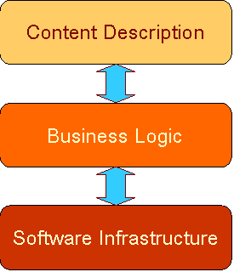

- Content Descriptions
  - Representation formalisms for semantic descriptions of contextual information on paid contents, such as organizational, administrative,and process issues.
  - Representation formalisms for contract descriptions.
  - Grounding of semantic descriptions in foundational ontologies.
  - Formal models for content processing and reasoning that are compliant with semantic descriptions.
- Business Logic
  - Analysis of content strategies and value chains for paid content & services ventures.
  - Analysis of impact of semantic web technologies on business models and value chains.
  - Design of visual end user languages for interaction with semantically rich and distributed paid content environments.
  - Design of open protocols for paid content trading and contract monitoring.
  - Support for the definition of contract monitoring policies (from lenient to rigorous)
- Software Infrastructure
  - Content-related contract interpretation engine
  - Semantic web services for contract negotiation and contract monitoring.
  - Integration of web content repositories and distribution channels.
  - Integration of payment services.
  - Integration of collaborative business process software

Key elements of SIPACO are
- Explicit semantically rich contract models for paid content (properties and features of paid content, tasks that are associated to paid content, modal logic descriptions)
- Negotiation protocols for paid content (→ library)
- Contract monitoring protocols for paid content (→ library)
- Foundational semantic negotiation and mapping between semantic library and catalog services
- Open, distributed infrastructure with different transportation binding for paid content, such as Peer-to-Peer, …
  - contracting services (contract negotiation)
  - contract monitoring services (payment, logistics, IPR management, royality management, arbitration, syndication, termination)
  - integration of information services (catalog and library services) and signaling services
- Ontology-based domain end user language (visual graph modelling); end user language will be used for push (publish/subscribe scenarios) and pull (request/response) scenarios of paid content distribution.
- service interface descriptions (structured pre- and post-conditions) [Marc: does your email mean you want to leave this out.?]
- [Marc: please integrate into module description/state of the art and keep only a short description here.] The description of a service interface according to an ontology should reflect the functional nature of a service by providing a semantic description in the form of pre- and post-conditions (a style of description also known from contract-based programming). The language for describing pre- and post-conditions should allow developers to build complex structures over the terms of an ontology and not only be based on single input and output concepts as they are provided by today’s technologies. The advantage of supporting complex pre- and post-conditions is that the ontology itself can contain very common and basic terms of business (which may be rather stable), and interface descriptions can combine these terms in an individual way to express their specialized semantics (behavior). Thus, we achieve stability in the ontology and flexibility in describing innovative services.
- [Marc: please integrate into module description/state of the art and keep only a short description here.] Existing ontology languages like OWL or DAML+OIL are industrial standards to enable the creation of ontologies. OWL-S (formerly DAML-S) is based on OWL and provides an ontology markup language to represent capabilities and properties of Web services. Its goals are to achieve automatic Web service discovery, invocation, composition, and execution monitoring. OWL-S is for describing a Web service based upon three basic types of information: provider information (simple contact information), functional descriptions, and further information for specifying the characteristics of a service (mainly by references to existing taxonomies). The most interesting part for the description of a service interface is the functional description. It describes the input, output parameters, and additionally pre-conditions (called external conditions that must be true for the execution of a service) and effects (called side effects of the execution of a Web service). The pre-conditions and effects are logic formulas to restrict the input and output parameters. That means, the functional description isdescription is on the same level as a WSDL document of a service, it does not yield information on the service’s semantics according to a standardized ontology.
- [Marc: please integrate into module description/state of the art and keep only a short description here.] Furthermore, the description of a service interface should be based on models. Models provide abstraction from the detailed problems of the implementation technology and allow users to focus on the more abstract tasks. In the field of software engineering, the diagrams of the industry standard UML (Unified Modeling Language) have become very successful and are now an established part of system’s development. Models are becoming even more crucial to software development as implementation artefactsartefacts can automatically be generated from the models, thus saving time and guaranteeing consistency. Offering modeling support for the description will have several further advantages: (1) Models are independent of the target language(s). It is thus possible to derive the different specifications/implementations consistently from one source. (2) Models are visual. Structures (like ontologies) can be understood much more intuitively if they are presented in a visual manner (as compared to pages of OWL code). Software engineersengineers have long since recognized this feature of visual languages and make heavily use of it. In the semantic Web field this idea resulted in UML class diagram representations which are equivalent to DAML+OIL or OWL specifications. (3) Models are becoming more important and a number of tools for using models in the field of software engineering are available. Basing the description of service interfaces on models allows one to reusereuse existing information and tools.

SIPACO will address three different applications domains that will be blended by an integration scenario.

- (Re)Construction of the paid content and paid service value chain
  - (Re-)Configuration of media industry value chains for paid content by semantic web services
  - Unleashing hidden paid contents by easy deployment via semantic web services
  - Innovative business models and content strategies for paid content
- Embedded publishing
  - Value added content around products and services
  - Innovative collaborative business models and content management strategies for paid content (SME compatible)
- Consumer centered publishing
  - Configuration of paid content and paid services around consumer needs
  - Application in mobile usage environments
- Integration scenario
???

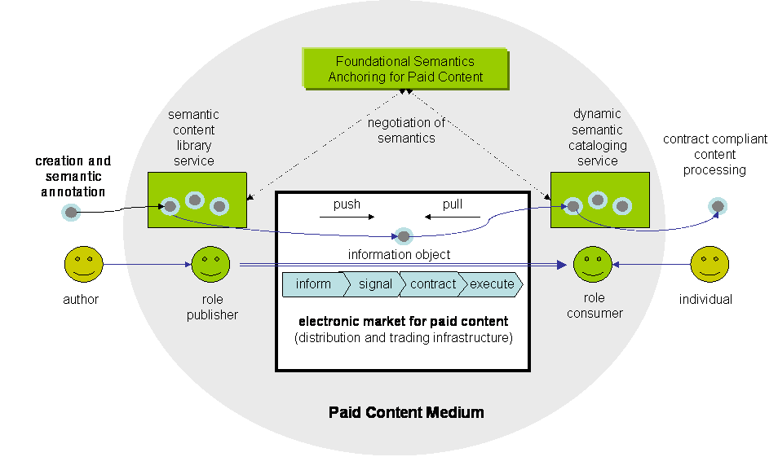
Figure 1: Overview SIPACO

For the identification of available content sources we will develop end-user languages that on one hand easily allow the specification of premium content that a user is looking for and on the other hand can be translated into requests that can be used by semantically enriched services in web-based environments. Because semantic web retrieval formalisms such as RDQL presuppose dedicated technical training, widely-used content environments require easy-to-learn user languages that efficiently facilitate content-oriented requests.
End-user languages or domain-specific languages [who marked this text?] are often tailored to a particular group of users or problem domain. They are specific for a user group.or domain throughthrough the appropriate use of notations and abstraction.. End-user languages are developed by usability and language engineers together with domain experts for people or scenarios where the development of solutions in a general purpose language is often a too daunting task for people typically not trained as software engineers. In principle, visual languages as opposed to textual ones would often be ideal for use as end-user language. For a large number of specialist user groups there exists a natural and intuitive visual representation of artefacts in their domains, which is often what practitioners in these fields have been using all along, which reduces training costs and lowers the barriers to acceptance.

[Wolfgang → Marc]
This end-user language is translated by a two-step process via a graph language into underlying semantic web representation formalisms. This provides an innovative, layered approach by integrating the strengths of the visual modelling capacities of graph languages with emerging interoperability of semantic descriptions of content and services in web environments.
Graph languages serve in our approach as a general purpose language that can be used by software engineers. Additionally, language engineers can use this graph language as abstract syntax for specifying new visual end-user languages. That means, the graph language serves as a language middleware that is independent from the implementation language and the end-user language. The working hypothesis is that this graph language will be designed in a way that its expressiveness will be sufficient for the identification and description of available content sources. End-user languages may be less expressive, depending on the end-users’ anticipated tasks when using the language. They will typically differ in notation and may provide only restricted views on the language middleware of what is relevant to the end users. Software engineers can directly use the graph language for specifying their solutions.
The abstract syntax of the graph language will be defined by defining an adequate meta-model. As an architectural basis we will use the Unified Modeling Language (UML). The UML becomes increasingly important as a modelling language across various domains like multimedia application design or workflow modelling. The UML offers meta-modelling support for developing domain-specific extensions. The domain-specific meta-models allow language designers to add more semantic depth to the standard meta-model and thus build a foundation for model analysis and code generation. The good meta-modelling support within the UML enables developers to seamlessly integrate new extensions into CASE tools and build special-purpose solutions outside of the standard UML applications.
The abstract syntax of the graph language (e.g. the meta-model extension of the UML) is then used for defining a translation into semantic web representation formalism. Because of the layered approach different semantic web representation formalisms can be used without changing the end-user language.

Figure 2: layered approach

Requests are propagated to web services by binding them to different transport layers, such as peer-to-peer or directory-based approaches (e.g., UDDI). Within SIPACO we will implement a paid content infrastructure on the basis of different transport systems and evaluate within concrete application domains which types of business models can be supported.

Figure 3: layered approach

Responses are semantic descriptions of digital content that provide information on which business and trading rules apply (business requirements) and how the content can be used (organisation and task environments). This information is organised by local aggregation services that provide dynamic catalogues to users (→ dynamic semantic catalogue services). [template approaches?]

Users will evaluate semantic descriptions of aggregated content offerings and enter into trade interactions with selected providers on the electronic market by signalling their interest. Trades will be based on trading protocols that are specified by business requirements of selected content product. Trading protocols govern the communication between trading agents with the goal to generate a mutually agreed contract or to exit from negotiations. Not in all cases, agents will use a common ontology for trading. Therefore communications mediated by a trading protocol will be translated into ontological languages of participating agents (→ negotiation of semantics). This translation process will be guided by a foundational ontology approach that provides a minimal ontological denominator between web services (→ foundational semantics anchoring for paid content).

The intermediate graph representation language provides means for high-level specification of pre- and postconditions (design by contract approach) that are to be satisfied by semantic annotations of content products hosted in heterogeneous and distributed web service environments.

This architecture provides an innovative and unique infrastructure for semantically annotated premium digital content that can be traded in distributed business environments.

[Exploitation issues]

The project should define a seamless technology framework and environment, which is unobtrusive and easy to use, robust and suitable for everyday use. The framework must allow flexible and rapid customization to the desired needs and socio-economic background. It should be easy to manage and maintain (regard it as a kind of utility such as telephone or power-supply) over the complete lifecycle of the project. It must be easy, simple and cheap enough that also SMEs can participate. It requires collaboration across organisational boundaries as well as different IT infrastructures.

Another key aspect is understanding the computational and knowledge resources or background information, required by individuals and communities within the project; and combining available resources as required. Another aspect is to be aware of the individual skills and resources contributed by each partner starting from the partner selection process over the whole lifecycle of the project (react to changes).

Main Research Topics

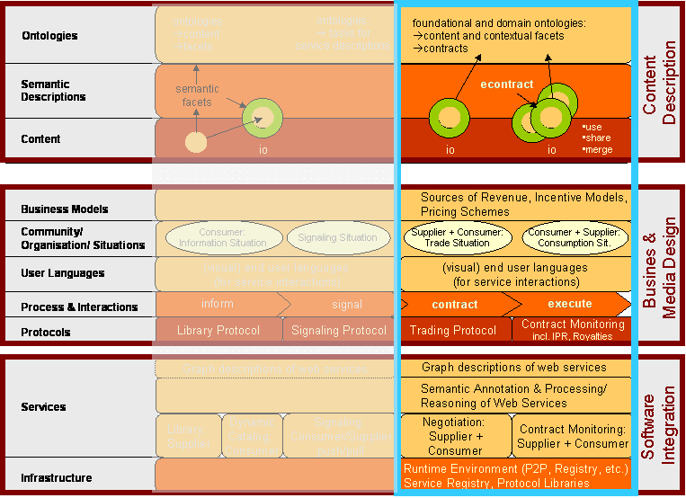
figure 4: SIPACO landscape (draft)

Module Content Descriptions

C: Foundational semantics (negotiation and contracting) [N.N.]

[→ WMA: contract descriptions]
[→ Wolfgang: Semantic contract for paid content: POSL, BPEL, PIC, ]

Semantic modeling and description of IPR issues
Semantic modeling of rights inventories
Semantic contract modeling and management
[Torsten: please describe the graphics and relate it to other descriptions.]

IP
Intellectual Property
Describes only the ‚work‘, e.g.
Song of Composer Z
Novel X by Author Y
Motion Picture „XYZ“
English Dictionary
Tennis 2000 – ‚the Film‘
...
IP Right(s)
Intellectual Property Rights
Describes the ‚rights‘ on the ‚work‘, e.g.
To produce motion pictures based on the novel X by Author y
To ... distribute, sell, license, ...
... Throughout the world ...
... in any and all kinds of media ...
such motion pictures
To produce and publish ... Or licence to produce and publish ... In any medium ... In any language ...the ‚work‘

Written by Brad Wright
Right for TV, worldwide
(1.2) Screenplays
IP Right
IP
Screenplay

Novel
IP
IP Right
Written by: Hugo B.
Right for TV,
Interactive~, US, Canada
(1.1) Novel
(1) acquire underlying rights (for future title):

From underlying
Rights contracts
Motion Picture
‘XYZ’
IP
(2) Create IP Motion Picture
IP Right
Right for TV, US, Canada
Derived from underlying rights
(3) Create IP Interactive Game
IP
IP Right
Right to sell,
Canada
Derived from underlying rights
Interactive Game ‚XYZ‘
Composed by Arthur Wright
Right for Interactive~,
NOT in US
IP
IP Right
Music
(1.3) Music

IP Right(s)
IP
IP
IP Right(s)
IP
IP Right(s)
Sales view
IP
IP Right(s)
Utilization
(where used,
composed of)
Product
Product
products
Product
license
rights
services
services
„Container“ for associated rights
Collector for costs & revenues
SAP would bring in its experience in modeling IPRM issues for various industries (IBU Media)

Module Business and Media Design

This module on business and media design focusses on three different levels:
- [EB] General economic model, media framework and business models for "Semantic Web"-based media firms
  - Analysis of use contexts (decision making, e.g., knowledge supply models: issue management, EIS,… ; embedded publishing: digital product designs,…)
- [MD] Media design: web-based organisationals designs and processes for paid content businesses
  - Analysis of the impact of semantically annotated content and service infrastructures on paid content value chains and potential for innovative business models.
  - Design of media organisations and processes for "Semantic Web"-based commercial media networks
  - Specification and design of generic e-contracting services for information goods in general and for paid contents in particular
  - Service design for generic e-contract monitoring
- [VL] (Visual) end-user languages

Workplan:
- Review ([EB])
  - formal models of e-contracting, e-contracting management and negotiation protocols
  - business models for paid content and paid services
  - ontological models for e-contracts
- Formal ontological model for web-based e-contracts ([→ content description level])
- Economic model and media framework for "Semantic Web"-based media firms [EB]
  - traditional media industry
  - media networks
  - private paid content networks
- Specification and design ([MD])
  - generic contracting service for paid content (e.g., MPEG-7/21, games, pictures, documents)
  - generic contract monitoring service
  - negotiation protocol for paid content
  - contract monitoring protocol
- Business modelling for three application domains ([EB])
- Evaluation of business models ([EB])
- Impact analysis on media industry ([EB])
- End user languages [Marc] ([VL])

Web-based semantic contract modelling for paid content [MCM, …]

[→ WMA: information object = paid content + contracts (→ discussion on naming: KCOs etc.)]

[→ WMA: electronic contracts for paid content]

[→ WMA: prospective/pre-sales and concession contracts]
Paid contents do not have to exist before signing a contract on paid contents. Hence, electronic contracts on paid contents can be separated into two classes: (1) contracts that govern the production (prospective/pre-sales contracts or short p-contracts) and (2) contracts that govern property and usage rights of paid contents (concession contracts or short c-contracts). An example for c-contracts are job contracts that generally regulate how future paid contents are appropriated on an abstract level [WMA: example from content industry]. Consulting contracts generally integrate p- and c-contracts. Procedural elements such as milestone plans or project management plans that determine procedural elements of digital content production whereas constraints on intellectual property rights constrain how digital contents are handled after production.
Thereby the focus lies on concession contracts with direct translations of traditional contracts into digital domains that govern packaged digital products. For instance, packaged software products are traded online on the basis of "webwrap", "clickwrap" or "point-and-click" agreements [Berenstein, Campbell'02]. Electronic contracts are a crucial element for specialisation and cooperation on market structures. They are time limited, procedural, legally binding interfaces to capacities that are provided by digital services. As any contract, they represent voilitions between economic actors to exchange digital contents of a certain quality in a mutually agreed and enforable manner. Digital contents and exchange behaviour are represented by quality descriptions of intended assets and description of procedures how paid contents are to be produced and exchanged.

[Implicit and explicit contracts]
At the eve of fully automated electronic contracts, we will distinguish between explicit and implicit contracts. Explicit contracts are fully formalised and assertive in a particular market situation for paid content. In contrast, implicit contracts are grounded either in social agreements that are not explicated in the situation of a content trade or in overarching explicit contracts that are not used in the particular market process. Therefore, the difference between implicit and explicit contracts is the level of ambiguity. The result of this phase is a binding contract including obligations and rights on both sides as far as they are not already defined by overarching contracts. If the situation is dominated by social ties contracts will be implicitly defined whereas formal relations of paid content market situations tend to use explicit contracts. The execution of contracts is performed during the execution phase in which information is exchanged against direct or indirect values (reputation, altruism, reciprocity [Davenport, Prusak'98]). The result of this phase is the correct termination of a business transaction, i.e. a successfully executed contract or a mutually agreed form of cancellation of the transaction.

[Media framework]
In the following, we present an integrated framework for the production (p-contracts) and usage (c-contracts) of paid content according to negotiated contracts.
The "Media Reference Model on Paid Content (MRM-PC)" provides a means for constructing electronic contracts for paid contents. As discusses above, contracts are abstractions on digital contents with enforceable operational interfaces. Digital contents that pre-exist before a voilition of economic actors can be traded by c-contracts (figure 5). In the other case, a compound contract is required consisting of a p-contract and a c-contract.
[→ WMA: figure and description of MRM-PC]
For existing paid contents, such as documents, p-contracts are reduced to delivery operations. P-contracts are abstract programs that control implementations. Paid contents are produced as side-effects of p-contract implementations. Each paid content is bound to at least one c-contract.

figure 5: Digital content binding with contracts
In a situation Sp of an electronic market place for paid contents, two economic actors, customer C and supplier S, agree on a p-contract for generating (G) a digital content DC that will be available for usage (U) under a set concession contract Cx in situation Sx (igure 1). The digital content DC might be re-committed to other concession contracts for a particular situation Sx.

[→ WMA: Tasks on paid content according to contract facet]
- create
- commit, re-commit
- modify
- copy
- delete

[Paid content services → to be decided whether paid content services will be part of SEPACO]
Dominantly digital contents are comitted to exactly one c-contract that is persistent over time. In cases that economic control requires an artificial limitation of content duplication or the nature of the provided content is functional, digital content is integrated into paid content services (PCS). Examples are node-locked software systems, online learning courses based on application service providing, online games, and video streams that cannot be downloaded [WMA: examples from media industry].

Based on this, we define a paid content service PCS as a relation over digital contents PC that are provided by this service, p-contracts P, a set c-contracts C and situations S. For digital content services that pre-exist, P will be empty. Similar to contracts on service-level agreements (e.g, [Farrell+'04]), p-contracts determine procedures for the generation of digital content services. Activities by actors and interactions between actors are determined on a conceptual level similar to the approach proposed by [Oberle+'04].

Paid content must be seen according to services as a kind of delivery channel. A unified view on content and services may include service level agreements as part of contracts.

Business Process Integration for instant using CRM or procurement functionality

[Service description: creation, negotiation, signing, monitoring (execution), maintenance,arbitration, termination]

[Negotiation services]
Economic actors ascertain intended economic behaviour by negotiating and signing contracts. Negotiation is a means for economic actors to communicate and compromise to reach mutually beneficial agreements [Pruitt'81]. [→ WMA: negotiation services]

[contract network; merging contracts; propagation]
[WMA/SAP?: IPR modelling; royalty accounting; process integration; …]

Negotiation and contract monitoring protocols […, MCM, …]

visual end-user language and service interface descriptions [Marc]

What about natural language interfaces? Esp. for specification of rights and contracts, something like Controlled English (e.g. CLCE) could be helpful to enable non logical but subject matter experts to specify contracts and rules.

Business Models for Paid Content Media Companies

See above. This research issue should be one of the first (in terms of the time scale) in the project.

Flexible business models for paid content (subscriptions, pay-per-view, pay-per-download, limited access, etc.) based on the needs of the application partners within the project.

Module Software Infrastructure
[Wernher, Marc, Sara, Rupert: please review and add]

An open, distributed infrastructure for paid content [Sara, Wernher, Marc, Rupert]

The fundamental issues to be addressed for any content related business over computer networks must take into account the following roles (and their interests):
- the creator of the content (or a proxy acting on their behalf) wants to be reimbursed for any usage of the content
- the provider wants to ensure authorised access to lawful content, and law-abiding usage of the content
- the producer / publisher who commissions the creation of content
- the collective management societies who act on behalf of creators by documenting, licensing, collecting royalties, gathering information on the use of works, monitoring and auditing, distribution of royalties to members
- the rights holder of the content wants to be informed of any usage of the content
- the consumer wants transparency of the cost associated with the content (e.g. paying levies for machinery that can be used for copying and then paying for the content itself, is double billing)
- the legislator wants a legal framework that is easily understood by all parties
- the legislation enforcement agencies want an infrastructure that allows "legal forensics"
- the citizens' rights agencies want an infrastructure that guarantees citizens' rights (police cannot enter anybody's house without a search warrant, so why should agencies be allowed to enter my hard disk?)
- society and the public at large wants business opportunities and ways to be creative, rather than being unduly limited by "property speculation" in the content markets (Greece would be a very rich country if there was an eternal copyright on the works of Aristotle, and the Arab countries would also be very rich if there was a license fee on the decimal system).

All of the above interact with each other in value chains and their interactions are governed by laws as well as contracts between the parties.

The current state of the art in DRM is focused on entertainment (films, music, games). There is some discussion about DRM in news publishing, but there is virtually no discussion of knowledge based media content. This must be seen against the statements made at a series of EC workshops on DRM, in 2002 and 2003. The players in the field agree that different DRMS are in place for different business models. An illustration from Julian Durand's (Nokia) presentation suggests a segmentation along the time and value axes:
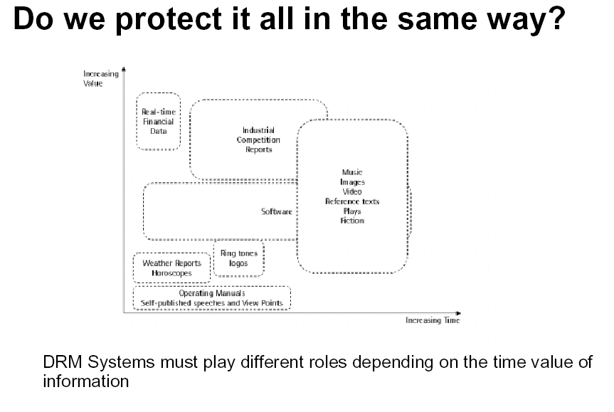
Source: Julian Durand (Nokia), Presentation at EC DRM Workshop Series 2002

The field of interest for SIPACO is the high-value, medium to long-term content asset, where commercial damage is potentially high if the content is "stolen" and redistributed for free, and where the consumer expects long term re-use and immediate availability of the content once they have purchased the rights to it. This places the research interests of SIPACO clearly within the objectives of a knowledge based economy, possibly beyond 2010, and it separates our research interests from mass consumer DRM solutions for the home market, although some of the lessons to be learned in SIPACO may also inform the field of traditional DRM technologies.

Another issue is the type of contract and license management one wishes to use: In the mass consumer markets, the state of play is to shrink-wrap license, content protection and the content itself, in software packages which are typically poor for interoperation and reuse (even legal reuse is often hindered!). For SIPACO, long term availability of purchased content must be possible. This means that shrink-wrap environments are not sufficient, because the user must be able to migrate premium content from legacy platforms to new computing environments without having to hope that the supplier of the original DRM machinery is still in business to convert the protected content into its new protected format. Furthermore, it should be possible to separate protection mechanism from content, so as to allow for a competitive market. This means a separation of contract, protection, and content. Such separations have well understood equivalents in the physical world: we protect money from being copied, we protect small sums by using purses which we carry around fairly closely guarded, and we entrust banks with managing larger sums of money on our behalf. Last but not least, the state usually guarantees that when a new currency is introduced, old values will be converted to the new one without loss.

The above separation of concerns calls not only for a distributed, but also for a dynamically reconfigurable IPRM, DRM and CPM architecture. The following building blocks act as our starting point:

<figure of building blocks - visualisation: to be done>
- Paid content repository
- Paid content presentation client
- Paid content contract repository
- Paid content contract / rights negotiation engine
- Paid content encoding system (encryption, watermarking, uniqueness-coding)
- Paid content delivery protection system (access limitations, authorisation)
- Paid content usage tracking system
- Paid content billing system
- Paid content forensic system
- Paid content migration system
- User awareness of contractual commitments for paid content

The following high level requirements can be identified for the building blocks of a paid content contract environment:

  - The paid content repository must be secure enough for premium content not to be compromised (e.g. stolen) "at source".
  - The paid content presentation client must be dynamically configurable for different kinds of protection mechanisms. For the legitimate user, paid, protected content must be as usable as any unprotected content, and the usage may only be monitored in an unobtrusive fashion within the legal constraints w.r.t. data protection.
  - Each actor in the value chain for paid digital content has a repository of the contracts / licenses to which s/he is committed
  - Each paid contract system (producer, broker, or consumer) has a rights negotiation engine which allows the system to enter into valid and lawful contracts
  - Each content publisher may use different encoding systems - according to the publisher's policies - in order to protect or mark the content they sell
  - Each actor in the value chain for paid digital content uses open systems that allow different vendors of protection systems to compete for trustful content protection (including trusted delivery!).
  - Certain agencies may be given powers to track usage of content within clear legislative boundaries, with the aim of reimbursing the rights holders of content.
  - Certain agencies may be given powers to communicate with usage tracking agencies for billing purposes.
  - Certain agencies may be given powers to use data forensics to track and prove unlawful use of content.
  - Paid content must be insured against loss through deprecation of the usage environment. Therefore, producers have an obligation to provide ways for lawful migration of content from one platform to another.
  - Paid content environments can be run in different modes and according to different policies: lawful usage may be fully enforced at the client; it may be monitored and deviations may be reversible; or it may neither be monitored nor tracked (trusted usage).
  - As the end user gathers more and more content with different licensing schemes and usage contracts, lawful usage becomes more and more difficult, leading to defensive behaviour. The project therefore proposes a contractual commitment visualisation component which allows users to get a clear understanding of what commitments (possibly liabilities) they have on their computing equipment. This is of course, also of significant interest to corporate users.

An advanced environment for paid content will be able to support different enforcement modes and business models. SIPACO will provide a semantically rich, distributed infrastructure that allows for maximum flexibility while maintaining high standards of trust and security, in a balanced fashion.

ISSUE (wb): should we use agent based models for the interaction between the different actors and the roles they play? The option is to use web service orchestration as the mechanism to describe complex behaviour, or to use agents as the software proxies of the above software building blocks (implementation may still be using semantic web services where available)

ISSUE ((wb → ALL )- where do DRM clearinghouses fit in?

ISSUE (wb → WMA ) MISSING BIT - discussion of WSMO in next version

ISSUE (wb → WMA) MISSING BIT - reference list - in next version

IPRMS must work in a networked business; therefore we need a common framework and infrastructure for IPR issues consisting of common APIs and protocols. This framework/infrastructure must sit on top of actual standards for Web and DRM (additional level of encapsulation). The infrastructure must be scalable, reliable and secure. SAP would like to participate in architectural discussions and the specification of APIs and protocols.

Based on the semantic models we need implementations of (or extension of existing) Intellectual Property Rights Management Systems for collaborative business based on premium content. Advanced concepts have be considered with regard to conventional IPRM systems in order to achieve a harmonized integrated solution.
- Packaging and encapsulation of semantic description and content data.
- Authoring support for acquisition of semantic descriptions of content.
SAP would like to work on innovative IPRM systems integrating semantic modeling concepts.

IPR managment is one of the key business areas of most media and knowledge intensive companies
- costs of content acquisition are rising dramatically
- management of available content and its exploitation is becoming increasingly important
- license revenue is a big part of the revenues and media companies have to ensure the correct payment of incoming royalties
- royalty payments to rights holders have to be correct
- packaging and re-packaging of content makes these processes even more complicated
- many of companies are using licensed content and have to pay royalties. Licensors have to make sure that they get their money

Royalty accounting for use of mixed sources based on royalty agreements.

Media Asset Procurement

Includes all processes and functions dealing with purchasing of intellectual property. Business Partner Management as well as Contract Management and Purchase Order Management were part of this subject.

Rights /License Sale
Covers all processes and functions dealing with selling of rights and their corresponding intellectual properties. Business Partner Management as well as Licensee Contract Management.

Utilization Repository
The utilization repository represents an inventory of acquired rights. All information concerning an intellectual property can be accessed from there. I.e. Rights Availability, Collisions, Exploitation Request for a media asset , assigned Business Partner, the type of right, the assignment of rights to media Assets, free and taken windows of rights and also the tracking of utilization.

Rights Availability Calculation
Is a certain right available according to restrictions, ownership situations and through contracts which are already in force?

Application Domains

- (Re)Construction of the paid content and paid service value chain
  - (Re-)Configuration of media industry value chains for paid content by semantic web services
  - Unleashing hidden paid contents by easy deployment via semantic web services
  - Innovative business models and content strategies for paid content
- Embedded publishing
  - Value added content around products and services
  - Innovative collaborative business models and content management strategies for paid content (SME compatible)
- Consumer centered publishing
  - Configuration of paid content and paid services around consumer needs
  - Application in mobile usage environments
- Integration scenario
???

Integration of Research Issues

??? will be the overall research goal for SIPACO. Topics A, B, and C focus onto contracting issues that are associated with trading of paid content as the important keystone of electronic markets for information goods. Topic A addresses semantically annotated data structures of contracts that are generic and flexible enough to represent static and dynamic control information for governing the use of paid content. A contract is perceived as an intrinsic part of paid contents. This compound object is called an information object. The dynamic aspect of a contract describes steps and methods by which a content can be used and modified.

In SiPaCo the term knowledge covers the whole range from meta-data about knowledge i.e. what, where, and how knowledge is available in a … environment to formalized knowledge representations such as ontologies themselves. This section will describe the three key fields of
- Knowledge XXX.

State-of-the-art and how SIPaCo will enhance it

Content Description Level
[Stefano, Aldo: ontology/semantic annotation]

[Wolfgang: Ontologicial enrichment of electronic contract] [Wolfgang → Stefano, Aldo]
Services that serve simple types of paid contents have been implemented by database systems [Griffith+'03]. By merging database approaches, distributed systems and approaches in semantic networks, an integrated field called semantic web has been founded that attempts to make information sources more readily accessible via digital networks to automated processes by adding meta-information that describes provided information [Berners-Lee'99, Horrocks, Patel-Schneider'03]. Automated processing and reasoning requires that meta-information is formalised which is approached by using ontological representation formalisms such as OWL [Dean+'02]. Ontologies extract important concepts and relations in a domain of a digital contents. From an economic viewpoint, ontologies provide a means to gain precise and formalised information on digital contents.
Ontologies provide a partial means to circumvent this economic problem of valuing experience goods by providing structural information that can be evaluated in combination with exogenous market information. Hence, ontologies support and influence price evaluation and negotiation strategies on demand side [Abecker+'03].

[➔ state of the art]

[➔ enhancements]

[Torsten: …]

[Wolfgang: contract in information systems theory and media theory]

[→ WMA: Contract representations: EDI, LegalXML, UN/CEFACT, ebXML, VirtO (U. Frankfurt), SeCo, COSMOS/OCTANE, INCAS (Tan/Thoen 2000, Lando2000), Petri nets, STD, PIF, IDEF, CIMOSA, Conceptual Graphs (→ UPB?)]
[→ WMA/???: Legal ontologies: Lexdata (2003), ]

Business and Media Design Level

A: Web-based semantic contract modelling for paid content [MCM, …]

[➔ state of the art]

[Economic argument: paid contents == information good]
Controlled commercial exchange of paid content becomes a key issue for knowledge-based economies. In traditional economics, control is given by contracts that are mutually agreed by participating economic actors. Contracts are enforceable agreements of economic actors on future activities. This economic construct is an enabler for efficient and effective trading of goods. Contracts specify general terms and objectives of a relationship and specify mechanisms for decision making and dispute resolution [Milgrom, Roberts'92]. The introduction of the Internet enforced to transpose the concept of a contract into electronic markets by designing electronic contracts. With the awareness that knowledge is becoming more and more an economic resource [Mentzas'04, Skyrme'01], the need for electronic contracts on content trading arises. In traditional markets, contracts on paid content are weakly structured and apply to simple types of paid content only. For complex digital contents, such as produced by consulting contracts, electronic contracts are required to become formalised and therefore more explicit. Following traditional economic theories, electronic contracts are key enabler for the reduction of uncertainty by transparency which results in efficient electronic markets for paid contents with effective pricing. In more detail, contracts are either implicitly defined by frame contracts, such as intellectual property rights, or by explicit agreements between both actors.

[contracts organise electronic markets]
An electronic contract describes agreements that are the result of communications and interactions between economic actors on community level. They orchestrate behaviour of actors and services over time and space. In a more abstract sense, electronic contracts provide interfaces to underlying behaviours and services. Therefore contracts are means for abstractions on economic behavioural level. Traditionally research on electronic contracts investigated uncertainties and risks during contract formation and actor legitimacy [Berenstein, Campbell'02, Davidson+'01, Pacini+'02].
[State-of-the-Art: contract representation and processing]
A large number of approaches from various areas have been proposed for contract representation. During early days of e-commerce, first-order predicate logic [Lee'88] coupled with documentary Petri nets and object-oriented models [Griffel'98] have been explored. Recently, Molina-Jimenez et al. use finite state machines (FSM) for representation of electronic contracts [Molina-Jimenez+'03]. They perceive contracts as distributed programs that are implemented on each role of a contracting situation. FSM affect each other by exchanging events that trigger operations and transitions in FSM's of other actors. Contract FSM's operate on entities that are stored in an underlying information middleware.
In a similar approach, [Cook+'02] use concepts from distributed systems theory to implement a controlled mechanism for information sharing between organisations. Exchanges are governed by protocols that interrelate object-providing services.
Milosovic and colleagues used various formalisms for representing electronic contracts, such as "behavior trees" [Milosovic, Dromey'02] and temporal logic [Marjanovic, Milosovic'01] that are applied to domains such as airline alliance agreements and service contracts.
In the context of provisioning of computational resources, service-level agreements are used for describing contractual and most of all temporal and event-dependent relationships between economic actors. [Farrell+'04] use a simplified form of the event calculus. They use norms as templates which constrain contractual statements that explicitly represent contractual agreements.

[→ WMA: contract for project execution: SIMO 3]
[→ WMA: trading / contracting protocol: FIPA contract net protocol, BPML, RuleML, POSL, …]
[→ WMA: Negotation: DOC.COM, Kersten/HICSS03, ]
[→ WMA: Dispute resolution: Alternative Dispute Resolution (Bahruka/Fisher01), OASIS LegalXML Online Dispute Resolution]
Research on Semantic Web investigates general purpose representation formalisms based on XML and inference mechanisms (DAML consortium, Agent ML committee, W3C semantic web Activity). Under the umbrella of "SweetDeal", [Grosof+'99] integrate various Semantic Web approaches by rule-based representations of contracts by using declarative semantics based on an extended form of ordinary logic. This approach allows explicit representation of semantics of rule sets which describe conclusions that result from a set of pre-conditions. Inference mechanisms are invisible to interacting actors. Contractual rules are represented by "situated courteous logic programs" that are encoded by RuleML. Process ontologies are presented by description logic encoded in OWL. This approach is domain-independent and allows to determine simple pre-conditions of contract that must be met before contract execution. SweetDeal provides a general-purpose formalism for procedural knowledge on electronic commerce but obtain weak control mechanisms for distributed environments.
An evidence-based approach represented by Subjective Logic for establishment and implementation of electronic contracts is provided by Daskalopulu et al. [Daskalopulu+'02]. Based on the Dempster-Shafer theory, believes on domain propositions are evaluated in order to identify gaps between contractual agreements and activity implementation. This approach supports human contract controllers in domains which allow partial fulfilments of contractual agreements.
In another approach to semi-automated electronic contract, Konopnicki et al. [Konopnicki+'02] represent contractual agreements by tree-structured graphs which are processed by a unification mechanism. This approach can be seen as a subform of Grosof's SweetDeal formalism.
Grosof's approach relates to advanced description logic representation formalisms as proposed by [Masolo+'04, Oberle+'04] that can be used for the representation of socially contructed entities, such as actors, by foundational ontologies. This approach allows to describe plans by roles, tasks and their interrelations. Plans are instantiated and executed on situation level by domain-dependent objects and events. By using this formalism, contracts could be described on description level with relations to entities on situation level.
Most of these works are rather independent from the question which kinds of goods are traded. None has explicitly taken into account the particularities of paid content [Abecker+'03].
We will now describe an integrated media model for electronic markets for paid contents before formal types of electronic contracts for knowledge trading are introduced.
Market transactions are aggregated activities that are designed to efficiently support optimal equilibria of economic needs of participating economic actors. Generic transactions can be divided into four phases: (1) information phase, (2) signaling phase, (3) agreement phase, and (4) execution phase [Schmid, Lindemann'98]. Electronic markets for paid contents encompass situations when actors discuss and execute contractually defined transactions on paid contents. All participating parties negotiate common and conflicting interests which are settled by a mutually agreed contract that determines future behaviour, i.e. exchange of paid content and other economic resources. Intensive research has focussed on economic [Milgrom, Roberts'92] and computational model [Fatima+'04] for negotiation. In the paid content domain, the aim is to discuss requirements for electronic contracts that support human or computational actors exchange of digital contents.
In a first phase … [WMA: productisation process of digital content].

B: Trading and contracting protocols […, MCM, …]

[➔ state of the art]

[➔ enhancements]

C: Foundational semantics (negotiation and contracting) [N.N.]

[➔ state of the art]

[➔ enhancements]

D: Graphical, ontology-based end-user language and service interface descriptions […, UPA, …]

[➔ state of the art]

[➔ enhancements]

E: Dynamic semantic cataloging […, MCM, …]

[➔ state of the art]

[➔ enhancements]

F: Open, distributed infrastructure for paid content [N.N.]

[➔ state of the art]

[➔ enhancements]

G: Business models for tradtional and innovative media industries [MCM, …]

[➔ state of the art]

[➔ enhancements]

Software Infrastructure Level

[Wernher, Sara, Marc, Rupert]

Relevance to the objectives of the IST Priority

Something

Something more

Potential impact

Outline implementation plan

Description of the Consortium

Description of project management

Project resources

Detailed implementation plan – first N months

Other Issues

Gender Issues

References

