SIPACO: Semantic Infrastructure for Paid Content (STREP, SO 2.4.7.)

Motivation
The small but fast growing market for paid content (and paid services) is fragmented, heterogeneous, and typically, based on proprietary technical service infrastructures for content protection and rights management. This fragmentation creates obstacles for interoperation and thus, impedes the creation of added value based on the premium content. The value of premium content would be increased if it could be easily found, retrieved and syndicated, if it could be adapted to the needs of specific user groups, if it was possible to guarantee certain contractual commitments, and if it was possible for systems to semi-automatically negotiate certain rights and obligations.

Current content formats, such as MP3, PDF, JPEG, carry some meta data but they do not contain business models or contractual descriptions. Instead, this information is embedded in underlying, bespoke software infrastructures. Hence, if content is transmitted to consumers, content and business information is disconnected so that economic control must be maintained either manually, or in parallel through mostly proprietary digital rights management (DRM) systems. Currently, premium content is just traded by simple "over-the-counter" business models (e.g., Spiegel Online, Wallstreet Journal) which do not maintain any contractual commitments after the initial transmission (Stahl et al. 2004).

A hurdle for the development of thriving markets for paid content is the lack of appropriate transaction mechanisms that support search, trade, usage and control of premium content so that suppliers can implement sustainable business models and users can efficiently obtain information about content properties and can efficiently use purchased content.

In SIPACO, we will focus on the trading of paid content and on the system-based monitoring of resulting contracts, with a view to providing an infrastructure for controlling the use of paid content in an unobtrusive and transparent manner, supporting an equilibrium of provider and consumer rights. While current commercial solutions are primarily geared towards music, films and games, the focus of SIPACO will be on knowledge based media content. This kind of content can take different forms, e.g. as a stand-alone product (e.g. dossiers on specific themes, as exemplified by Spiegel on-line) or as an additional service component of other products, such as advanced maintenance know-how for technical machinery.

Goals of SIPACO
As acknowledged in the work programme for S.O. 2.4.7, there is an increasing awareness that content needs to be enriched by meta data and knowledge structures in order to become a value proposition in the emerging knowledge economy. Just as crude oil is not sufficient to be used directly in cars, content needs to be enhanced and supported by a sophisticated infrastructure before it can become "fuel" for economic growth.

We will focus on two important aspects of paid content value chains:
- trading situations of paid content and
- contract monitoring.

During a trading situation a consumer and a vendor will be supported by information on the
(a) utility of content in respect to intended application situations,
(b) usage modalities,
(c) business requirements, and
(d) requirements on runtime environments.

Contract monitoring is a key element of any market infrastructure for paid contents that grounds contractual commitments of a premium content in use situations and evaluates their legality and contractual validity.

The goal of SIPACO is to develop a paid content infrastructure that is based on semantic web technology. Semantic web formalisms grounded in foundational ontologies will be used in SIPACO to describe and process, product information and contracts. Since current semantic web formalisms cannot be used by ordinary users, one work package will develop user languages based on visual metaphors that hide the underlying formal semantic web descriptions. Paying specific attention to the usability aspect of the proposed technology, we target one of the biggest problems of the semantic web initiative, namely the embedding of knowledge technologies in more mature and thus, better understood methodologies. Part of the work will, for example, investigate how visual graph-oriented languages can be used for semantic web service designs. With these elements we intend to design and implement an open semantic web service-oriented architecture that allows the integration of content repositories, trading of content and monitoring of contracts.

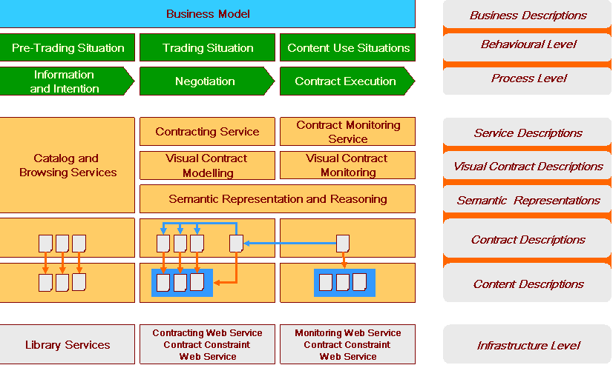

The work plan of SIPACO will be structured as follows:
(1) Content description technologies - in particular, for contract related information;
(2) Process descriptions - in particular, the specification of business models that will "host" certain contracts
(3) Execution environments - in particular, reasoning services that are specialised for contract interpretation

- Content Descriptions
  - Representation formalisms for semantic descriptions of contextual information on paid contents, such as organizational, administrative,and process issues.
  - Representation formalisms for contract descriptions.
  - Grounding of semantic descriptions in foundational ontologies.
  - Formal models for content processing and reasoning that are compliant with semantic descriptions.
- Business Logic
  - Analysis of content strategies and value chains for paid content & services ventures.
  - Analysis of impact of semantic web technologies on business models and value chains.
  - Design of visual end user languages for interaction with semantically rich and distributed paid content environments.
  - Design of open protocols for paid content trading, content fusion and contract monitoring.
  - Support for the definition of contract monitoring policies (from lenient to rigorous)
- Software Infrastructure
  - Content-related contract interpretation and processing engine
  - Semantic web services for contract negotiation and contract monitoring.
  - Integration of web content repositories and distribution channels.
  - Integration of payment services.
  - Integration of collaborative business process software

SIPACO will address three different applications domains that will be blended by an integration scenario.

- Reconfiguring of a value chain for paid content and paid services
The purpose of this application is to demonstrate the ability of constructing new value propositions
through the use of a flexible contract management system.value chain
  - (Re-)Configuration of media industry value chains for paid content by semantic web services
  - Enabling the provision of paid content through easy deployment via semantic web services
  - Innovative business models and content strategies for paid content

- Embedded publishing
The purpose of this application is to demonstrate how content industries and e.g. manufacturing are able to collaborate in enhancing products or their use and maintenance.
  - Enabling the creation of value adding content to enhance products and services
  - Supporting innovative collaborative business models and content management strategies for paid content (SME compatible)

- Consumer centered publishing
The purpose of this scenario is to show the reuse of premium content for mobile users through flexible contracts.
  - Configuration of paid content and paid services around consumer needs
  - Application in mobile usage environments

- Integration scenario
The purpose of the integration scenario is to demonstrate the permeability of content related business cases through the use of executable contract specifications. We aim to show how at least two of the above application domains can be cross-fertilised, in business terms, through flexible and machine supported contract negotiation and contract monitoring.

Scientific and Technological Challenges of SIPACO
- Move from shrink-wrapped "canned" solutions (contract, content, and business model are inseparable) to flexible and interoperable solutions for digital content products - e.g. contract merging through content fusion.
- Use constraint propagation networks during contract negotiation and monitoring for consistency matching of contractual conditions and activity selection.
- Develop a semantically rich web service infrastructure in which contract specifications can be enacted
- ... (more ?)

Exploitation
- Domain specific paid content markets
- Paid content networks
- Knowledge sourcing channels
- .... (more?)

Partners in SIPACO

 | Research | Implementation | Integration | Application / Use
University of St. Gallen, Switzerland | X | X | X
University of Paderborn, Germany | X | X | X | x
Salzburg Research, Austria | X | X | X | x
SAP, Germany | X | X | X
LOA-CNR Rome, Italy | X
Telefonica |  |  | X | X
A.P. B |  |  |  | X
A.P. C |  |  |  | X

European Benefit

(wb: Please add reasons why this research needs to be carried NOW and at EUROPEAN level)
- Paid content and services are a fast growing market that lacks enhanced contracting services which would support content syndication and other secondary utilisations.
- Huge potentials of premium contents become available with easy-to-use and low-cost electronic contract infrastructures.
- Contracts need to work in heterogeneous environments which requires (semi-)automatic translation of contracts. This is facilitated by semantic descriptions and reasoning mechanisms
- Electronic contracts are complex information structures that need presentations on different levels. Visual representations facilitate contract preparation, contract fusion and contract monitoring.
- …

